During development of the Contact, Task, and Appointment service classes, I deliberately operated in two modes: the meticulous engineer focused on meeting every requirement, and the adversarial tester intent on breaking whatever I built. Switching between these mindsets allowed me to anticipate failure points, design more resilient logic, and create test cases that pushed the system far beyond the happy path. This dual-role approach ultimately strengthened the reliability and robustness of the entire application.
1. Contact Service:
The core objective was to validate the system’s ability to reliably add, delete, and update contact records, with particular emphasis on how the application handled malformed or incomplete data. I deliberately stressed the boundaries of the Contact Service by introducing null values, incorrect data types, and other edge-case inputs to confirm that error handling behaved as expected. Because the project requirements imposed strict constraints on how contact information must be stored and validated, it was essential to verify that each field, especially the first name, which serves as a key identifier in several workflows was processed correctly.
Example of code:
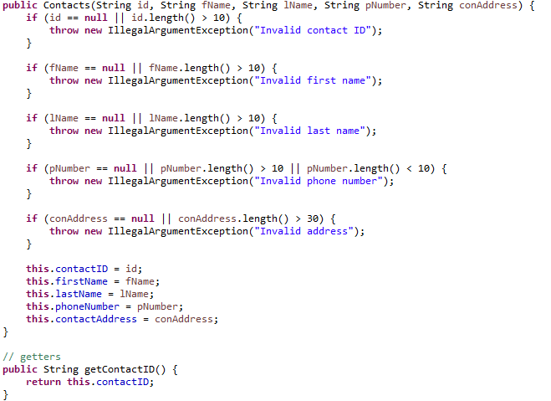
2. Task Service:
The goal was to rigorously verify the system’s ability to add, update, and delete tasks while ensuring full compliance with the established specifications. This included validating rules around attribute uniqueness and enforcing length constraints. Each task must contain a unique identifier, a name, and a description, all of which are subject to clearly defined limits and validation requirements.
Example of code:
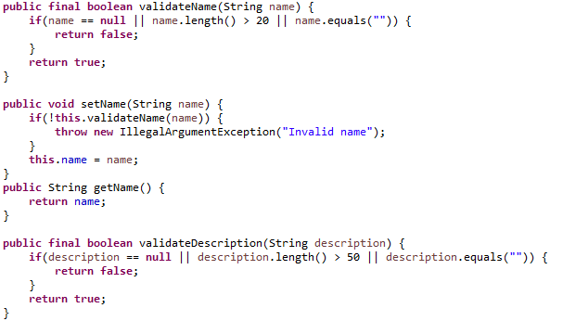
3. Appointment Service:
The tests for Appointment Service concentrated on validating the creation of new appointments, emphasizing strict handling of both date and description inputs. Because appointment scheduling depends heavily on accurate temporal data, the Calendar verified that invalid or past dates were rejected and that only properly structured, non-null descriptions were accepted. These checks ensured the service enforced all business rules around appointment creation, preventing malformed or logically inconsistent entries from entering the system.
Example of code:
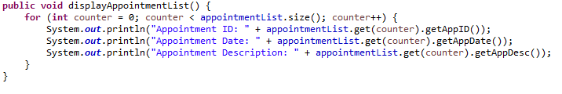
I did not achieve 100% passing on every test I created. I focused on validating the core functionalities especially getters, setters, and critical constructor logic. These components are foundational to the stability and reliability of the application, so achieving full coverage in these sections was intentional and essential.
Example of code: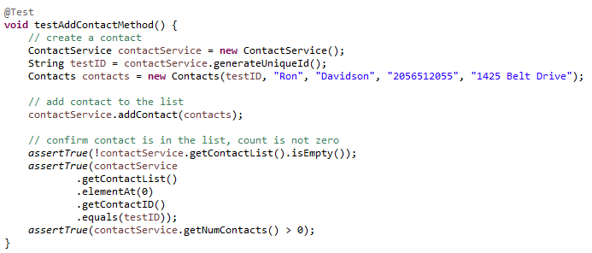
My testing approach focused not only on achieving functional correctness but also on ensuring the robustness and reliability of the entire test suite. I placed strong emphasis on maintaining a clean and controlled test environment; consistent cleanup ensured that each test remained fully independent and free from side effects.
To improve efficiency, I streamlined the tests by grouping related assertions, reducing redundant operations while still validating multiple dimensions of functionality. For example, when adding a contact, the test simultaneously verified both the addition itself and the resulting list size capturing more insight with fewer steps.
I incorporated both unit testing and static testing. Static testing allowed me to evaluate the code against specifications early, catching potential issues before execution. My unit tests were intentionally rigorous, designed to challenge the implementation by probing boundary conditions, error handling, and unexpected inputs. I approached testing with the mindset of trying to break the code rather than simply confirming it worked, which helped uncover subtle issues and strengthen overall resilience.
By acting as both the developer and a critical external reviewer, I worked to counteract the natural bias of assuming my own code was correct. This dual perspective supported a more objective evaluation of quality and reliability.
This disciplined, no-shortcuts approach to testing directly contributes to the long-term stability of the software. Comprehensive coverage, consistent testing standards, and ongoing code reviews help reduce technical debt and support sustainable development. Maintaining this level of rigor is essential not only for the success of the current project but also for future scalability and maintainability.

